

**International School**

**Capstone Project 2**

CMU-SE 451

**Database Design**

**Version 1.0**

**Date: 20/02/2024**

**Smart Recruitment System**

**Submitted by**

**Dat, Nguyen Thanh**

**Thang, Nguyen Tran Anh**

**Khoa, Doan Ngoc Anh**

**Quang, Tran Minh**

**Approved by**

**Hoang, Nguyen Thai**

**Proposal Review Panel Representative:**

Name Signature Date

**Capstone Project 1 - Mentor:**

Name Signature Date

**PROJECT INFORMATION**

|  |  |  |  |  |
| --- | --- | --- | --- | --- |
| **Project acronym** | IIJF | | | |
| **Project Title** | Ittelligence IT Job Finding | | | |
| **Start Date** | 15th Feb 2024 | **End Date** | 27th May 2024 | |
| **Lead Institution** | International School, Duy Tan University | | | |
| **Project Mentor** | Mr. Hoang, Nguyen Thai | | | |
| **Scrum master / Project Leader & contact details** | Tuan, Nguyen Anh  Email: tuanquynh1111050102@gmail.com  Tel: 0975523135  ID: 26211235098 | | | |
| **Partner Organization** | Duy Tan University | | | |
| **Project Web URL** |  | | | |
| **Team members** | Name | Email | | Tel |
| 26211242012 | Dat, Nguyen Thanh | nguyendat16111210@gmail.com | | 0352694246 |
| 26211229940 | Tri, Le Minh | leminhtri2002@gmail.com | | 0395967905 |
| 26211233669 | Duyet, Pham The | duyetpham322@gmail.com | | 0705235603 |

**REVISION HISTORY**

|  |  |  |  |  |
| --- | --- | --- | --- | --- |
| **Version** | **Date** | **Comments** | **Author** | **Approval** |
| 1.0 | 20/03/2024 | Update Database Design Document | Dat, Nguyen Thanh |  |

Table of Contents

**1. Introduction 1**

1.1. Purpose 1

1.2. Goal 1

1.3. Scope 1

1.4. Data storage platforms 2

1.5. Definition, Acronyms and Abbreviations 2

**2. Database Design 3**

2.1. Table Overview 3

2.2. Collection Diagram 4

2.3. Detail 5

2.3.1. User 5

2.4.2 Candidate 6

2.4.3 Employer 7

2.4.4 Job 8

2.4.5 Schedule 9

2.4.6 Message 10

2.4.7 Category 11

2.4.8 Feedback 11

2.4.09 Resume 12

2.4.10 Notification 12

2.4.11 Transaction 13

2.4.12 Apply 14

2.4.13 Search 14

2.4.14 SubCategory 15

2.4.15 WorkPositionWeight 15

**3. References 16**

1. **Introduction**
   1. **Purpose**

Place information system’s database design document describes structure of database and file structure of system. Database Design document will introduce all attribute the System that will help developer and tester base on this design to implement and test.

* 1. **Goal**

To create database tables most accurate.

* 1. **Scope**

This Database Design Document provides the basic for “Smart Recruitment System” Database design.

It describes both logical and physical definition, non-functional issues, and the database interfaces; storage aspects are defined in the physical database design sections.

The tables performance considerations requirements. The following topics are covered in this document:

* Assumptions and decisions on database design.
* Entity-mapping.
* Table column definitions.
* Primary, unique and foreign key definitions.
* Column and row level validation rules (check constraints).
* Rule for populating specific columns (sequences, derivations, demoralized (column)).
* Interfaces and dependencies with other components.
* Data access description.

The database design for “Demark – Decentralized Market” is composed of definitions for database objects derived by mapping entities to tables attributes to columns, unique identifiers to unique keys and relationship to foreign keys.

During design, these initial definitions are enhanced to support the functionality described in the functional specification/ user stories and defined in the primary and supporting modules of the application high level design.

* 1. **Data storage platforms**

- Data of application is stored in MongoDB database

- In MongoDB , data structure is stored as tables that the database objects that behave as containers for the data, in which the data will be logically organized in collections and documents format.

* 1. **Definition, Acronyms and Abbreviations**

|  |  |  |
| --- | --- | --- |
| **Abbreviations** | **Description** | **Comment** |
| PK/FK | Primary/ Foreign Key | Use to indicate a file is a Primary or Foreign key in a table |
| ERD | Entity Relationship Diagram | Show the relationship between entities in the system |

1. **Database Design**
   1. **Table Overview**

|  |  |  |
| --- | --- | --- |
| **No.** | **Table name** | **Short Description** |
| 1 | User | This collection stores all information of Users |
| 2 | Candidate | This collection stores all information of Candidates |
| 3 | Employer | This collection stores all information of Employers |
| 4 | Job | This collection stores all information of Jobs |
| 5 | Schedule | This collection stores scheduled interviews for jobs |
| 6 | Message | This collection stores messages sent between candidate and employer |
| 7 | Category | This collection stores all information of Job Categories |
| 8 | Feedback | This collection This collection stores addresses of users, candidates, and employers |
| 9 | Resume | This collection stores resumes of candidates |
| 19 | Notification | This collection stores notifications for users |
| 11 | Transaction | This collection stores transaction information |
| 12 | Apply | This collection stores job applications from candidates |
| 13 | Search | This collection stores search information for jobs |
| 14 | SubCategory | This collection stores information related to subcategories |
| 15 | WorkPositionWeight | This collection stores information related to the weight of work positions. |
| 16 | ChatbotMessage | This collection stores messages exchanged between the chatbot and users. |
| 17 | ChatbotConversation | This collection stores information about conversations between the chatbot and users. |

* 1. **Collection Diagram**

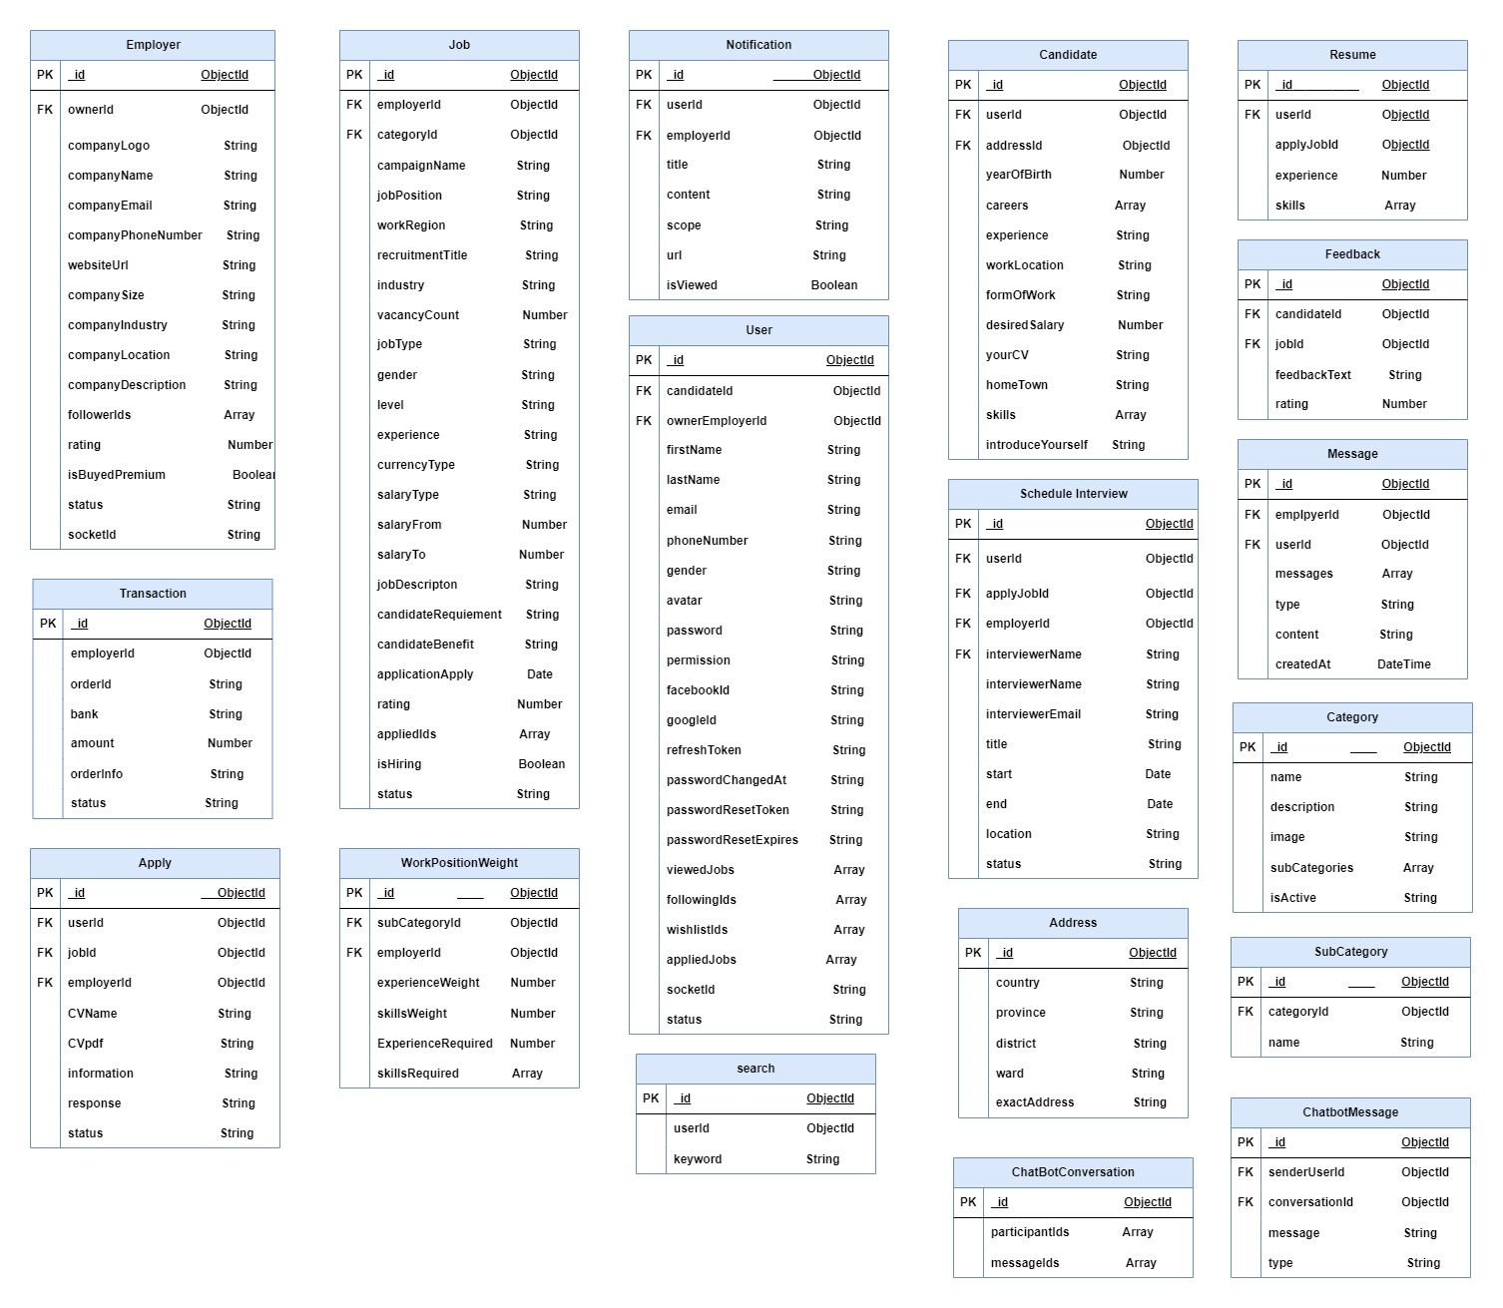

**Figure 1:** *Database Design Diagram*

* 1. **Detail**
     1. **User**

|  |  |  |  |  |
| --- | --- | --- | --- | --- |
| **Attributes** | **Datatype** | **Default** | **Description** | **Constraint** |
| _id | ObjectId |  | Unique ID of the document in MongoDB. | PK |
| firstName | String |  | Firstname of the user or individual. | Required |
| lastName | String |  | Lastname of the user or individual. | Required |
| email | String |  | Email address of the user, typically used for login. | Required, Unique |
| phoneNumber | String |  | Phone number of the user. |  |
| avatar | String | default.png | Path or data of the user's profile picture. | Required |
| publicId | String |  | ID of the avatar field | Required |
| sex | String |  | Gender of the user (male, female, other). |  |
| password | String |  | Hashed or encrypted password for security. | Required |
| permission | String | user | User's role or permissions in the system. | Required,  Enum: user, admin |
| viewedJobs | Array | [] | List of jobs that the user has viewed. |  |
| appliedJobs | Array | [] | List of jobs that the user has applied to. |  |
| followingIds | Array | [] | List of user IDs that the user is following. |  |
| wishlistIds | Array | [] | List of job IDs that the user has added to their wishlist. |  |
| candidateId | ObjectId |  | ID of the candidate in the case of recruitment. |  |
| employerId | ObjectId |  | ID of the employer or related business. |  |
| facebookId | String |  | User's ID on Facebook, if linked to the account. | Unique |
| googleId | String |  | User's ID on Google, if linked to the account. | Unique |
| refreshToken | String |  | Token used to refresh authentication tokens after expiration. |  |
| passwordResetToken | String |  | Token used for resetting the password when requested. |  |
| passwordResetExpire | String |  | Expiry time of the password reset token. |  |
| status | String | active | Account status (active, locked, etc.). | Required |
| createdAt | Date |  | Date and time when the document was created. |  |
| updatedAt | Date |  | Date and time of the most recent update to the document. |  |

**2.4.2 Candidate**

|  |  |  |  |  |
| --- | --- | --- | --- | --- |
| **Attributes** | **Datatype** | **Default** | **Description** | **Constraint** |
| _id | ObjectId |  | Unique identifier for the document in MongoDB. | PK |
| userId | ObjectId |  | User's ID. | FK, Required |
| jobPosition | String |  | Job position or title. | Required |
| experience | String |  | Description of the experience related to the job. | Required |
| workLocation | String |  | Desired work location or job location. | Required |
| skills | Array | [] | Array containing skills related to the job. | Required |
| desiredSalary | Number |  | Desired salary for the job. | Required, Min: 0 |
| yourWishes | String |  | Any additional wishes or preferences related to the job. |  |
| introduceYourself | String |  | Brief introduction or description of the individual. |  |
| createdAt | Date |  | Date and time when the document was created. |  |
| updatedAt | Date |  | Date and time of the most recent update to the document. |  |

**2.4.3 Employer**

|  |  |  |  |  |
| --- | --- | --- | --- | --- |
| **Attributes** | **Datatype** | **Default** | **Description** | **Constraint** |
| _id | ObjectId |  | Unique identifier for the document in MongoDB. | PK |
| userId | ObjectId (ref: "User") |  | User's ID associated with the company. | FK, Required |
| companyLogo | String |  | Path or data of the company's logo. | Required |
| publicId | String |  | Public ID or identifier for the company logo. | Required |
| companyName | String |  | Name of the company. | Required |
| companyEmail | String |  | Email address associated with the company. | Required |
| websiteUrl | String |  | URL of the company's website. | Required |
| coverImage | String |  | Path or data of the cover image for the company. |  |
| coverImagePublicId | String |  | Public ID or identifier for the cover image. |  |
| companySize | String |  | Size or scale of the company. | Required |
| addressId | ObjectId |  | ID associated with the company's address. | Required |
| companyDescription | String |  | Description or overview of the company. | Required |
| followerIds | Array | [] | Array containing IDs of users who follow the company. |  |
| rating | Number | 4 | Rating or score associated with the company. | Min: 1, Max: 5 |
| socketId | String |  | Socket ID for real-time communication. |  |
| isBuyedPremium | Boolean | false | Indicates whether the company has purchased premium status or not. |  |
| status | String | active | Current status of the company. | Enum: ["pending", "active", "locked"] |
| createdAt | Date |  | Date and time when the document was created. |  |
| updatedAt | Date |  | updatedAt (Date): Date and time of the most recent update to the document. |  |

**2.4.4 Job**

|  |  |  |  |  |
| --- | --- | --- | --- | --- |
| **Attributes** | **Datatype** | **Default** | **Description** | **Constraint** |
| _id | ObjectId |  | Unique identifier for the document in MongoDB. | PK |
| employerId | ObjectId |  | Employer's ID associated with the recruitment campaign. | FK, Required |
| workRegion | ObjectId |  | Region or location where the work is based. | FK,Required |
| recruitmentCampaignName | String |  | Name or identifier for the recruitment campaign. | Required |
| recruitmentTitle | String |  | Title or name of the recruitment. | Required |
| industry | String |  | Industry associated with the recruitment. | Required |
| vacancyCount | Number |  | Number of job vacancies available. | Required |
| jobType | String |  | Type or category of the job. | Required |
| gender | String |  | Gender preference for the job (if applicable). | Required |
| level | String |  | Level or position of the job. | Required |
| experience | Number |  | Required experience for the job. | Required |
| currencyType | String |  | Type of currency for the salary. | Required |
| salaryType | String | VND | Type of salary (VND, USD). | Required |
| salaryFrom | Number |  | Minimum salary for the job. |  |
| salaryTo | Number |  | Maximum salary for the job. |  |
| jobDescription | String |  | Description of the job responsibilities. |  |
| candidateRequirements | String |  | Requirements for potential candidates. | Enum: ["pending", "active", "locked"] |
| skills | Array | [] | Array containing skills required for the job. | Required |
| candidateBenefits | String |  | Benefits offered to candidates. | Required |
| applicationDeadline | Date |  | Deadline for submitting job applications. | Required |
| status | String |  | Current status of the recruitment campaign. | Enum: ["pending", "active", "expired", "reject"] |
| isHiring | Boolean | True | Indicates whether the company is actively hiring. |  |
| appliedIds | Array | [] | Array containing IDs of candidates who have applied. |  |
| rating | Number |  | Rating or score associated with the recruitment. | Min: 1, Max: 5 |
| createdAt | Date |  | Date and time when the document was created. |  |
| updatedAt | Date |  | Date and time of the most recent update to the document. |  |

**2.4.5 Schedule**

|  |  |  |  |  |
| --- | --- | --- | --- | --- |
| **Attributes** | **Datatype** | **Default** | **Description** | **Constraint** |
| _id | ObjectId |  | Unique identifier for the document in MongoDB. | PK |
| userId | ObjectId |  | User's ID associated with this entry. | FK, Required |
| applyId | ObjectId |  | Apply's unique identifier. | FK, Required |
| employerId | ObjectId |  | Employer's ID related to the entry. | FK, Required |
| title | String |  | Title or name associated with the entry. | Required |
| start | String |  | Start date or time associated with the entry. | Required |
| end | Date |  | End date or time associated with the entry. | Required |
| location |  |  | Location or address associated with the entry. |  |
| interviewerName | String |  | Name of the interviewer. | Required |
| interviewerPhoneNumber |  |  | Phone number of the interviewer. | Required |
| interviewerEmail |  |  | Email of the interviewer. | Required |
| status | String | offline | Current status of the entry (online or offline). |  |
| createdAt | Date |  | Date and time when the document was created. |  |
| updatedAt | Date |  | Date and time of the most recent update to the document. |  |

**2.4.6 Message**

|  |  |  |  |  |
| --- | --- | --- | --- | --- |
| **Attributes** | **Datatype** | **Default** | **Description** | **Constraint** |
| _id | ObjectId |  | Unique identifier for the document in MongoDB. | PK |
| userId | ObjectId |  | User's ID associated with this entry. | FK |
| employerId | ObjectId |  | Employer's ID related to the entry. | FK |
| messages | Array of Objects |  | An array containing message objects. |  |
| sender | String |  | Sender of the message. | Required |
| type | String | text | Type of the message (e.g., text, file). | Enum: ["text", "link"] |
| content | String |  | Content of the message. | Required |
| createdAt | Date |  | Date and time when the document was created. |  |
| updatedAt | Date |  | Date and time of the most recent update to the |  |

**2.4.7 Category**

|  |  |  |  |  |
| --- | --- | --- | --- | --- |
| **Attributes** | **Datatype** | **Default** | **Description** | **Constraint** |
| _id | ObjectId |  | Unique identifier for the document in MongoDB. | PK |
| name | String |  | Name or label associated with the entry. | Required |
| image | String |  | Path or data of the image associated with the entry. | Required |
| publicId | String |  | Public ID or identifier for the image. | Required |
| description | String |  | Description or overview of the entry. |  |
| subcategories | Array |  | An array containing names or labels of subcategories associated with the entry. | Required |
| isActive | Boolean | true | Indicates whether the entry is currently active or not. | Default: true |
| createdAt | Date |  | Date and time when the document was created. |  |
| updatedAt | Date |  | Date and time of the most recent update to the |  |

**2.4.8 Feedback**

|  |  |  |  |  |
| --- | --- | --- | --- | --- |
| **Attributes** | **Datatype** | **Default** | **Description** | **Constraint** |
| _id | ObjectId |  | Unique identifier for the document in MongoDB. | PK |
| userId | ObjectId |  | User's ID associated with the feedback. | FK, Required |
| jobId | ObjectId |  | Job's ID related to the feedback. | FK, Required |
| employerId | ObjectId |  | Employer's ID related to the feedback. | FK, Required |
| images | String | [] | Array containing paths or data of images associated with the feedback. |  |
| publicIds | String | [] | Array containing public IDs or identifiers for the images. |  |
| feedbackText | Boolean | true | Text or content of the feedback. | Default: true |
| rating | Number |  | Rating or score associated with the feedback. | Min: 1, Max: 5 |
| createdAt | Date |  | Date and time when the document was created. |  |
| updatedAt | Date |  | Date and time of the most recent update to the |  |

**2.4.9 Resume**

|  |  |  |  |  |
| --- | --- | --- | --- | --- |
| **Attributes** | **Datatype** | **Default** | **Description** | **Constraint** |
| _id | ObjectId |  | Unique identifier for the document in MongoDB. | PK |
| userId | ObjectId |  | User's ID associated with the resume CV. | FK, Required |
| applyJobId | ObjectId |  | Apply Job's ID related to the resume CV. | FK, Required |
| experience | Number | 0 | Description of the user's work experience. | Required |
| skills | Array | [] | Array containing skills associated with the user. | Required |
| createdAt | Date |  | Date and time when the document was created. |  |
| updatedAt | Date |  | Date and time of the most recent update to the |  |

**2.4.10 Notification**

|  |  |  |  |  |
| --- | --- | --- | --- | --- |
| **Attributes** | **Datatype** | **Default** | **Description** | **Constraint** |
| _id | ObjectId |  | Unique identifier for the document in MongoDB. | PK |
| userId | ObjectId |  | User's ID associated with the notification. | FK, Required |
| employerId | ObjectId |  | Employer's ID related to the notification. | FK, Required |
| title | String |  | Title or heading of the notification. | Required |
| content | String |  | Content or message of the notification. | Required |
| isViewed | Boolean | false | Indicates whether the notification has been viewed or not. | Default: false |
| createdAt | Date |  | Date and time when the document was created. |  |
| updatedAt | Date |  | Date and time of the most recent update to the document. |  |

**2.4.11 Transaction**

|  |  |  |  |  |
| --- | --- | --- | --- | --- |
| **Attributes** | **Datatype** | **Default** | **Description** | **Constraint** |
| _id | ObjectId |  | Unique identifier for the document in MongoDB. | PK |
| employerId | ObjectId |  | Employer's ID associated with the transaction. | FK, Required |
| orderId | String |  | Unique identifier or order ID for the transaction. | Required |
| bank | String |  | Bank information or method used for the transaction. | Required |
| amount | Number |  | Amount of money involved in the transaction. | Required |
| orderInfo | String |  | Additional information or details related to the order. | Required |
| status | String | pending | Status of the transaction. | Enum: ["pending", "success", "failure"] |
| createdAt | Date |  | Date and time when the document was created. |  |
| updatedAt | Date |  | Date and time of the most recent update to the document. |  |

**2.4.12 Apply**

|  |  |  |  |  |
| --- | --- | --- | --- | --- |
| **Attributes** | **Datatype** | **Default** | **Description** | **Constraint** |
| _id | ObjectId |  | Unique identifier for the document in MongoDB. | PK |
| userId | ObjectId |  | User's ID associated with the job application. | FK, Required |
| jobId | ObjectId |  | Job's ID related to the application. | FK, Required |
| employerId | ObjectId |  | Employer's ID related to the application. | FK, Required |
| CVName | String |  | Name of the Curriculum Vitae (CV) associated with the application. | Required |
| CVpdf | String |  | Path or data of the PDF document containing the CV. | Required |
| information | String |  | Additional information or notes related to the application. |  |
| status | String | notviewed | Current status of the job application. | Enum: ["notviewed", "viewed", "accepted", "rejected", "progressing"] |
| createdAt | Date |  | Date and time when the document was created. |  |
| updatedAt | Date |  | Date and time of the most recent update to the |  |

**2.4.13 Search**

|  |  |  |  |  |
| --- | --- | --- | --- | --- |
| **Attributes** | **Datatype** | **Default** | **Description** | **Constraint** |
| _id | ObjectId |  | Unique identifier for the document in MongoDB. | PK |
| userId | ObjectId |  | User's ID associated with the search entry. | FK, Required |
| keyword | String |  | Keyword associated with the search entry. | FK, Required |
| createdAt | Date |  | Date and time when the document was created. |  |
| updatedAt | Date |  | Date and time of the most recent update to the |  |

**2.4.14 SubCategory**

|  |  |  |  |  |
| --- | --- | --- | --- | --- |
| **Attributes** | **Datatype** | **Default** | **Description** | **Constraint** |
| _id | ObjectId |  | Unique identifier for the document in MongoDB. | PK |
| categoryId | ObjectId |  | Unique identifier for the category associated with the entry. | FK, Required |
| name | String |  | Name of sub category | Required |
| createdAt | Date |  | Date and time when the document was created. |  |
| updatedAt | Date |  | Date and time of the most recent update to the |  |

**2.4.15 WorkPositionWeight**

|  |  |  |  |  |
| --- | --- | --- | --- | --- |
| **Attributes** | **Datatype** | **Default** | **Description** | **Constraint** |
| _id | ObjectId |  | Unique identifier for the document in MongoDB. | PK |
| subCategoryId | ObjectId |  | Unique identifier for the subcategory associated with the job requirement. | FK, Required |
| employerId | ObjectId |  | Employer's ID associated with the job requirement. | FK, Required |
| experienceWeight | Number | 0.5 | Weight or importance assigned to the experience requirement. |  |
| skillsWeight | Number | 0.5 | Weight or importance assigned to the skills requirement. |  |
| experience | Number | 0 | Desired level or type of experience required for the job. |  |
| skills | Array | [] | Desired level or type of experience required for the job. |  |
| createdAt | Date |  | Date and time when the document was created. |  |
| updatedAt | Date |  | Date and time of the most recent update to the |  |

**2.4.16 ChatbotMessage**

|  |  |  |  |  |
| --- | --- | --- | --- | --- |
| **Attributes** | **Datatype** | **Default** | **Description** | **Constraint** |
| _id | ObjectId |  | Unique identifier for the document in MongoDB. | PK |
| senderId | ObjectId |  | Identifier for the sender of the message. | FK, Required |
| conversationId | ObjectId |  | Identifier for the conversation associated with the message. | FK, Required |
| message | String |  | The content of the message. | Required |
| Type | String | Text | Message type (e.g. text, json, image, ...) |  |
| createdAt | Date |  | Date and time when the document was created. |  |
| updatedAt | Date |  | Date and time of the most recent update to the |  |

**2.4.17 ChatbotConversation**

|  |  |  |  |  |
| --- | --- | --- | --- | --- |
| **Attributes** | **Datatype** | **Default** | **Description** | **Constraint** |
| _id | ObjectId |  | Unique identifier for the document in MongoDB. | PK |
| participantIds | Array | [] | Array of identifiers of participants in the conversation. |  |
| messageIds | Array | [] | Array of identifiers of messages in the conversation. |  |
| createdAt | Date |  | Date and time when the document was created. |  |
| updatedAt | Date |  | Date and time of the most recent update to the |  |

1. **References**